Chapter 15 - Classification

Or why logistic regression is not regression

15.1 - Introduction
Congratulations, we've worked through how to find the best possible parameters for a linear regression model, given our training data. We can use the most basic statistics approach, which is straightforward to implement, even in Excel. The ordinary least squares matrix closed form solution is extremely power and has many use cases, beyond machine learning. My first go at any data set will typically be using that equation. It given a good sense of what your data is about, even though more complex algorithms outperform it substantially. Finally, the gradient descent solution we build here is a trivial use of gradient descent. It does not show off its elegance and strength as an algorithm. The combination of gradient descent and its neural network extension of backpropagation are still the core algorithms used in training machine learning models. With these new concepts being introduced we can move from regression to classification. Most of the methods remains the same, but we need a few tweaks to our algorithms to be make them suitable for classification problems. Specifically, we need different metrics of success, loss, error, and accuracy. To explore all that, we will implement the most well-known classification algorithms: logistic regression (and yes, it is a somewhat unfortunate name).

15.2 - A new activation function
In the previous chapter, we used linear algebra to predict an outcome value from inputs, transforming this input using trained parameters or weights. The input and parameters form a linear system, where the resulting output is weighted sum of the inputs with the parameters providing this weighting. Because of this, the resulting output was a continuous value. The first step in transitioning to classification is to transform such a continuous output into something discreet and binary. There are several functions that allow for this, but the most common used one is the sigmoid function. At zero, this function yields a value of 0.5, which can be interpreted as the predicted probability of class A (and by extension class B, since p_{A} = 1 - p_{B} because p_{A} + p_{B} = 1). Values greater than 0 will increase the probability of one class over the other, but this asymptotes out at 1. Similarly, negative values will eventually asymptote to 0. This conveniently bounds the output to a probability between 0 and 1. What is left is to simply threshold the value, anything input yielding a probability < 0.5 is predicted as class A, anything larger class B. However, since we are now outputting probabilities, rather than continuous values, we need to also rethink our loss function: the degree to which we adjust our parameters in response to a discrepancy between predicted and actual outcomes.

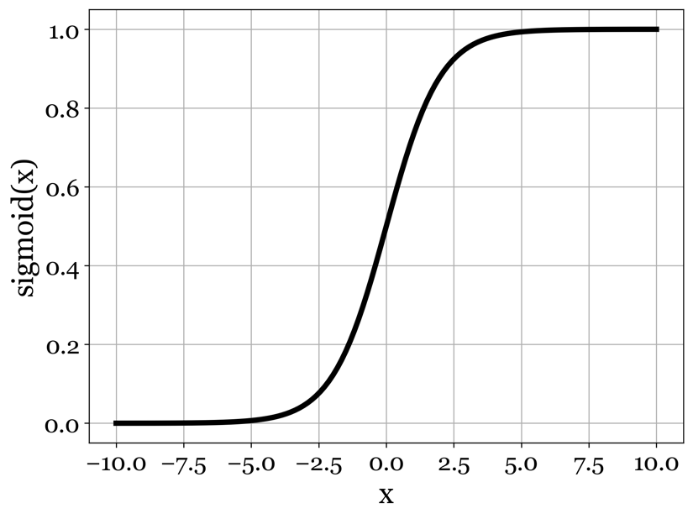
(15.1)
Equation and Figure 15.1 - The sigmoid function equation. The sigmoid function maps any continuous variable to an output bound by [0,1]. We use it to transform the linear component (the inputs weighted by their parameters, which is unbound, into probabilities. Thresholding these probabilities yields a binary prediction.

15.3 – A new loss function
In the previous chapter, we defined our loss function as the squared error between our model’s prediction and some ground truth value. The underlying assumption for this was that the error had a normal distribution. When we change our problem statement to classification, it is easy to see why this normal distribution no longer makes sense. Classification algorithms produce probabilities which are thresholded to yield classifications of data point. Unlike regression where we have a single output that can be compared directly with the ground truth by way of its difference, in binary classification we have two probabilities, one for each prediction. For example, in regression we might predict the asking price for a house based on its square footage, number of rooms and its location. The difference in asking price predicted by our algorithm and the actual asking price defines how well the algorithm is doing during training. The more it deviates, the more we adjust the weights to correct for it. However, if we were to use classification to predict whether a house has more than 4 rooms based on its asking price, we obtain two probabilities for each scenario: the house has more than 4 rooms (p_{A}), or it does not (p_{B}). By thresholding these output probabilities, we obtain an actual prediction. But the absolute difference between prediction and actual outcome in classification is a bit meaningless: 0 for correct predictions, and 1 for incorrect predictions. First, these errors are not normally distributed, as they are discreet in nature. Second, we would very much prefer a loss function that tells us not just that the algorithm was incorrect, but preferably also by how much it got it wrong, so when its parameters are updated during learning, they are updated proportionally to how poor the prediction was. Imagine that our model predicts p_{A} = 0.6 and p_{B} = 0.4. In this case the algorithm favors one decision over another, but isn't necessarily that sure about it, as the two probabilities are close to 0.5. This is a classification model's way of saying 'I am basically guessing '. Now, suppose that actual outcome in this scenario was that indeed the house had more than 4 rooms. If we had thresholded the two probabilities, we would have our model predict that this was the case and it would have been correct. Our model would have also been correct if the probabilities to produced were p_{A} = 0.9 and p_{B} = 0.1. And both would have been incorrect if the house did not have more than 4 rooms. Institutively, I hope you see how being correct isn't necessarily the whole story on how well our model did. We should factor in, somehow, the model's confidence in its prediction as well. Getting a prediction wrong when the algorithm is essentially guessing isn't all that bad, we can't fault it for not having enough signal in the data if there is none. But if it seems very certain about its prediction (probabilities close to 1) it should be penalized more strongly if it predicted the outcome incorrectly and rewarded more heavily if it did get it right. Turns out there is a way to compute this confidence weighted error: the log loss function.

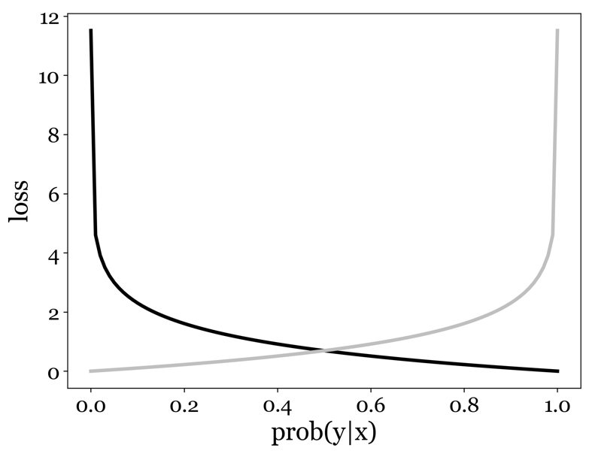

(15.2)
Equation and Figure 15.2- The log loss function. In this figure, we consider two possible ground truth scenario, in which the actual predicted output of our classifier should have been 0 (gray curve) or 1 (black curve). If the probability of us predicting 1 is low (and thus high for predicting 0), our log loss function returns a substantial loss for the when the actual outcome should have been 1, but almost no loss when the actual outcome should have been 0. As the probability of predicting 1 increases (towards the right of the graph), this scenario is reversed. The loss obtained using this function is thus proportional to our error (i.e., the difference between our prediction, our confidence in it and the actual outcome).

It might look a little complicated at first but plotting its behavior as a function of both the probabilities of our model's output and the ground truth shows its favorable properties. Each curve represents one of the two ground truth scenarios: the actual outcome was 1 (black) or 0 (gray). When both the predicted and actual outcome are the same, the resulting loss for that data point is 0. However, the more the probability produces by the model points towards the opposite outcome (0), the higher the associated loss. This thus guarantees we penalize the model proportionally to how incorrect it was, not just that it was incorrect.

15.4 - Introducing Logistic Regression
These two changes to the gradient descent algorithm we build in the previous chapter are all that is needed to move from regression to classification. We can and should use all the same techniques as were already touched upon. As before, we should make sure to divide our data into training and testing date to prevent overfitting. Finally, we will have to decide on learning rate, regularization parameters (if we are using regularization) and other hyperparameters that we need to explore to find the best of all possible algorithms. However, one important difference between this algorithm and the linear models we worked with in the previous chapters: the loss landscape is not convex: there is no guarantee that there is only one solution and that it will be found. There is a local minima to be found, and initial parameters can really make a difference in the resulting model and its accuracy. More importantly, since the statistical and algebraic methods need the loss landscape to be convex, we cannot use them here. This means that out of the 3 methods we used in previous chapter, only one is applicable here: gradient descent. The combination of gradient descent and our new log loss function transform our linear regression algorithm from the previous chapter into a classification algorithm: logistic regression. As you can tell, it is a bit of unfortunate misnomer, since it is not a regression algorithm in the way we have defined regression. It is, however, probably one of most central algorithms in machine learning. Mathematically, it has many similarities to the deep belief neural networks we will explore later. In fact, one way to imagine a modern DBNN is a neural network in which each node is essentially a tiny little logistic regression algorithm. Training a newly developed logistic regression model follows the exact same approach we outlined in chapter 14 for linear regression. The only difference is in how we define our loss function, and the extra step we take to transform the output of the linear operation on our data by the model, using the sigmoid function. We have included a few demo notebooks that implement logistic regression at various levels of coding complexity, and with different learning strategies (conventional, batch and stochastic gradient descent).

15.5 - Measures of success
Another important difference between regression and classification is on our measure of success. Understand how well a classification algorithm is performing is a bit more complicated than you might think. In fact, many misunderstandings arise from a focus on the wrong success metric. Models can perform exceptionally well, or so it appears, using one metric. They can be found to be faulty, unreliable, and even dangerous on closer inspection using more sophisticated methods. If you are not keen on all the mathematics we use throughout this book and don't think you will find yourself using or implementing any of the methods, you can of course skip many sections that deal with that. But if you have an interest in machine learning and AI, work closely with people how build and deploy them, and want to have a better understand how AI can introduce dangerous biases in society, we recommend the next few sections. We hope to encourage critical thinking when bold claims are made about AI. You will begin to question flashy headlines like: 'new algorithm accurately predicts the presence of an extremely rare cancer doctors were unable diagnose before!'. And for good reason.

15.6 - Measures of success - When accuracy falls short
So, what might we get wrong in trying to understand a model's performance?
There is a natural tendency to evaluate a classification algorithm by looking at its accuracy. Clearly, something with an accuracy close to 100% must be a good algorithm. Similarly, if it doesn't do better than chance, what is the point of having it? Things are far more subtle. Consider that before-mentioned algorithm in charge of detecting an extremely rare form of cancer through some form of measurement (medical imaging, biopsy, etc.). If I was particularly lazy and nefarious at the same time, I could just build an algorithm that return the same answer no matter what the input: the diagnosis is negative. The thing is, I would be right almost all the time. Because the cancer is so rare, most of the times I correctly predict the cancer is not present, but not intentionally.

15.7 - Measures of success - False, True, Negative and Positive
This imbalance between classes is a problem for classification algorithms, but there are ways around it. But first start by nuancing the idea that the algorithm is 'correct'. On closer inspection, a binary classification algorithm can be right in two way, and wrong in two ways. A true positive is when the algorithm correctly predicts the presence of something, like a cancer cell. But it can also correctly predict that absence of that same thing: a true negative. Likewise, an algorithm can get it wrong by predicting something that is not actually present (a false positive) and get it wrong by failing to do when it is present : the false negative). This creates a 2x2 matrix of these four possibilities for a binary classification example. For a multiclass problem, it is called a confusion matrix, where the matrix is n x n with n being the number of unique classes that can be predicted. In the binary case, two additional measures can be computed beyond that accuracy that tell a better story of how the algorithm is performing: precision and recall.

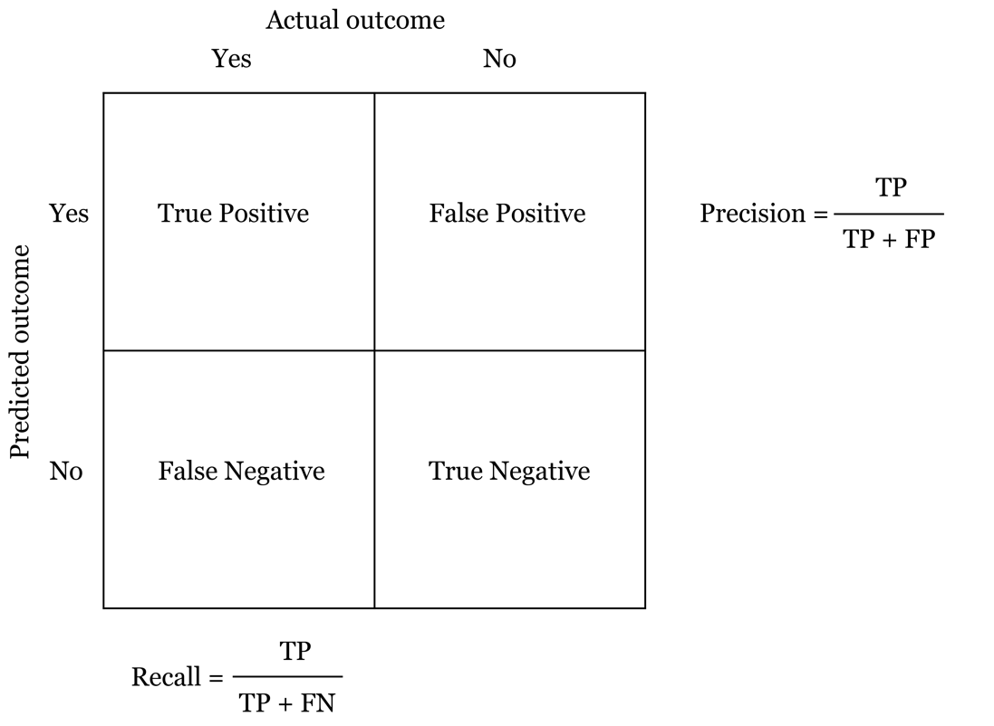
Figure 15.3 - Precision and Recall. In a binary Boolean classification task, there are four possible outcomes, 2 correct and 2 incorrect. True positives indicate the classifier correctly predicting the presence on an outcome, whereas true negatives are correctly predicting the absence. False positives mean the classifier incorrectly indicates the presence of the outcome, a false negative when the classifier incorrectly assumes the absence of the outcome. By combining these outcomes, we can determine both the precision and the recall of our classifier.

15.8 - Precision and recall
By unpacking being correct or wrong in our prediction, we can create a more nuanced set of metrics, called precision and recall. Imagine I am writing a paper on a topic X. To do so I need to find existing papers already on that same topic so I can reference them. Using some search engine, I ask for all papers on topic X. Now, topic X might be a little vaguely defined or broadly scoped, so the search engine will have to decide which one to include and which ones to exclude. The list it returns can be compared to two different thing. First, how complete is the list? Did the search engine accidentally leave some articles out that should in theory be relevant and on topic X? This ratio, between the list of articles I got and the total list of articles on topic X is called recall: the number of relevant items retrieved. In contrast, the search engine may have accidentally put some articles in my list that aren't about topic X. The ratio between all the articles returned and those that were actual about topic X is called the precision. The difference is subtle but important, especially in healthcare. Yearly mammograms are recommended for women over a certain age, but the problem is that mammograms often 'cry wolf'. That is, their precision is low: lots of false positives are reported causing extreme anxiety in people before additional testing proves it was indeed a false positive. In contrast, imagine that we are trying to predict the risk for a certain cancer based on basic demographics, like age, gender, race, height, BMI, education level. But in training the model, we use only data collected from students on the nearby university campus. The model will probably be reasonably accurate for other students at the same campus that our algorithm was trained on, but what about people from all other walks of life? It is very likely the algorithm will miss a lot of positives because it can't generalize properly. This is a problem in recall: the failure to flag a relevant event, yielding false negatives (as opposed to the false positives in a low precision scenario). You can tell both by the math and by intuition that a shift towards better recall will always degrade our precision and vice versa. It is up to you and the domain experts to decide what is more important. Luckily shifting the importance of either measure is very easily achieved by shifting the threshold we apply to the probabilities our algorithm puts on events. We can demand at least a probability of 0.8 before we decide the event is indeed present, which increases our precision. Or we can loosen our criteria and set the threshold to 0.2 to make sure we don't miss any relevant events, an increase in recall.

15.9 - F-Scores
One further way that is worth mentioning as a measure of success for classification algorithms is the F-score. The F1-score combines the precision and recall of a classifier into a single metric by taking their harmonic mean. It is primarily used to compare the performance of two classifiers. If that classifier A has a higher recall, and classifier B has higher precision, which one performs the best? By weighing precision and recall, the F-score provides a way to answer that question to some extent.

(15.3)
(15.4)
(15.5)
(15.6)
Equations 15.3 to 13.5 - Various measures of success associated with classification

15.10 – Area under the ROC curve
A final metric that can summarize the quality of a classification algorithm is the so-called area under the ROC curve. ROC stands for receiver-operator curve with its roots in information theory and was first developed by electrical engineers and radar engineers during World War II for detecting enemy objects in battlefields and was soon introduced to psychology to account for perceptual detection of stimuli. ROC analysis since then has been used in medicine, radiology, biometrics, forecasting of natural hazards, meteorology, model performance assessment, and other areas for many decades and is increasingly used in machine learning and data mining research. It aims to measure and illustrates the diagnostic ability of a binary classifier system as its discrimination threshold is varied. Imagine that we have two phenotypes that differ in whether they are at risk for a certain cancer. In addition, we have some other data we think might predict whether you are from one of these phenotypes, say BMI. Nature being nature, we expect there to be intrinsic noise, where people form a continuum of the predictive signal, but all in all they still represent two distributions. Imagine that population B is the one at risk for cancer, population A is not. However, the data we are using doesn't distinguish between these two populations. For example, we might assume that their height predicts the cancer phenotype. But when we plot these two distributions of height, they overlap completely. That means that no matter where we place our threshold that will predict whether someone belongs to group A or B,
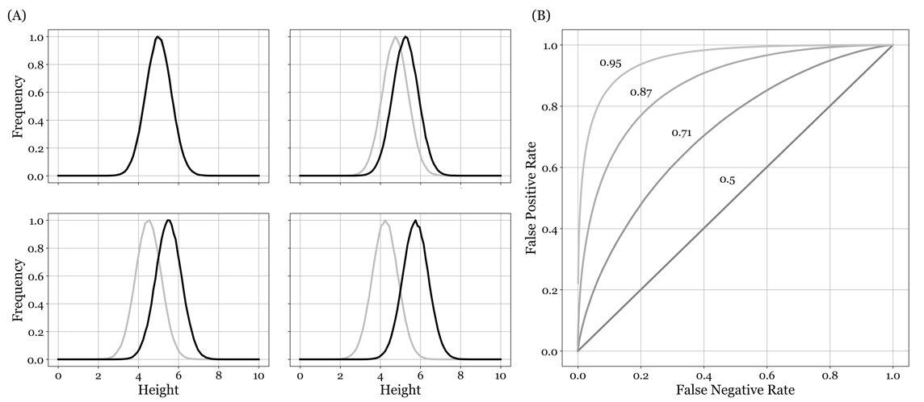
Figure 15.4 - Area under the ROC curve. (A) We aim to build a classifier that uses height to predict whether an individual is at increased risk for a certain cancer. This can truly work if the distribution of heights for the group at increased risk is indeed statistically different from the one for the group not at increased risk. Panel (A) shows that with a greater difference in mean, the two distributions start to separate, allowing for increasingly more accurate predictions. (B) By varying the threshold for predicting whether an individual is at risk, based on their height, we can create ROC curves for each of the four levels of separation seen in (A). Indeed, as the two distributions begin to separate more clearly, the area under the curve increases with it, indicating true predictive power.

we will be at chance. An ROC curve goes a bit further. Remember that the linear output of our classification model we have used so far (Logistic regression) is transformed using the sigmoid function. So, the range of possible heights our subjects can have is ultimately transformed to a number between 0 and 1. By varying our decision threshold between it, in small increments, we can compute at each threshold, two metrics, the true positive (TPR) and the false positive rates (FPR). The true positive rate is the ratio between the true positives (y_{pred} = 1 and y = 1) and the total number of positive outcomes (y = 1). The false positive rate is the ratio of the false positives (y_{pred} = 1 and y = 0) and the total number of negative outcomes (y = 0). If we plot these two values for a range of thresholds between 0 and 1, we will get a curve. What does this curve look like when we have no predictive power at any threshold? At low thresholds, we will always predict 1, so we have high false and true positive rates because we always predict a positive outcome. At high threshold, our positive rates (false or true) drop to zero, as we now almost never predict a positive outcome. This is true whether we were able to achieve some accuracy discriminating between these two populations. The key is to look at the threshold at 0.5. This is where we would ideally like to see our algorithm perform well and produce many true positives, and few false positives. But if there is no predictive power, this ratio will remain constant. And this is true no matter where we place the threshold. Graphically, this means that all points fall on the diagonal of TPR = FPR, creating a straight line from (0,0) to (1,1). Now imagine we have two distributions that are separated, indicating they do differ in terms of phenotype, based on our metric. In this scenario, we still expect the two edge points where the threshold is either 0 or 1 to be at (0,0) and (1,1). However, for a threshold at 0.5, we would now see the thing we had hoped for: the ratio between true positives and false positives is leaning heavily towards true positives. The more this is true, the more our resulting curve across many threshold deviates from the diagonal, its curvature more pronounced and stretched into the left-upper corner where we have the high ratio of true positive vs false positives. The area generated between this curve, and the diagonal is referred to as the Area under the Curve. And as our algorithm becomes better and better, this area will increase in size. The ROC curves for the above separation of above described and visualized gaussian distributions. As the separation in mean between the two distribution increases, the area under the resulting ROC curve will increase as well.

15.11 - Underfitting and Overfitting
Like regression, we should take care to prevent both underfitting and overfitting. Classification is not different from regression in how it mitigates these dangers. The best approach across all machine learning algorithms is to have independent datasets for training, testing and validation. What constitutes test and validation data isn't always clear, and the terms are used a little loosely. The best (and we would argue correct) definition is that a training data set is used to compute and apply changes to the parameters (weights) of our model. On each iteration, whether this an update from a single data point, a mini batch, or a pass through the entire training data, we use a test data set to compute the loss function that tells us how learning is progressing. And depending on our apporach, what constitutes as training data and test data can change. If we divide the data beforehand: one bit of our data will go into changing our parameters, the other bit will determine the necessary performance metrics like loss and accuracy. Finally, when applying the algorithm to the test data yields results that are acceptable, we once more run that algorithm, but now on the completely untouched and independent validation data set. This will yield a final and objective set of measure of success and quality. In some way, it is reminiscent of how many democracies are setup: our training data can be seen as the legislative branch, the testing data as the executive branch, and finally the validation data as the judiciary branch.

15.12 - Imbalanced classes
A very common problem when training a classification algorithm is the imbalance between the number of training examples you have for each class. Some events we are interested in predicting might indeed be quite rare. As we have discussed before, we should always be careful interpreting the output of these models and consider the a-priori probability (the probability of the things we are trying to predict independent of the input data the model uses). But there is an additional issue: our learning algorithms might also get confused. Remember that we are trying to minimize the loss: the overall error of our algorithm. But in an imbalanced data set, that error is going to be driven by the dominant class, and important but infrequent signals to a rare event are lost in the computations to optimize the parameters. This can lead to algorithms that underperform or even worse. The most stringent approach is to balance your data set using the class with the lowest number of examples. This is a sound approach but does potentially remove a lot of very useful data from your data set. Other approaches can weight data points according to their number or adjust loss function to account for the imbalances. We have same cases in which data sets were balanced by created copies of the outnumbered class to match the other classes. This is not correct. Yes, you are adding data points. But you are not adding new independent data. As a result, the statistics of this expanded data set are misleading to both you and the algorithm. The resulting model cannot be trusted.

15.13 - Multiclass problems
So far, we have only dealt with examples of binary classification tasks. In real world situations we often find ourselves classifying inputs into more than two categories. We can accomplish this by modifying the algorithm itself, but this will have our discussion encroach near much of what we will want to discuss in the context of neural networks, which serve as a natural extension of the logistic regression methodology in which multiclass problems aren't any different than binary ones, int terms of the implementation of the algorithm. It has also not been a standing tradition to alter the logistic regression algorithm itself to allow for multiclass problems. Instead, people have opted for two less efficient, but easier to implement strategies: one vs all and one vs one. The first method has us build as many logistic regression models as there are classes. And for each model, we pick one out n classes as the positive example in a binary classification task, while all the classes represent negative examples. In a three-class situation, we thus create 3 models: Class A vs Class B and C, Class B vs Class A and C and Class C vs Class A and B. Training isn't different from how we implemented this earlier, the only thing to take note of is that this approach will create an imbalance between classes for at least for some of the models we are training. Prediction is where we must do things a little different. Each new input is run through all models. One method is to pick the model that assigns the highest probability to the 'one' class. In this scenario, we might end up with a model that by itself doesn't even predict our class, but compared to the other models, still assigns it the highest probability. In other approach, referred to as one-vs-one, we training as many models as there are unique pairs of classes. In a four-way classification problem, we thus create 6 models (A vs B, A vs B, A vs C, B vs C and C vs D, and B vs D). To identify the predicted class in this situation, we now use a majority vote: which class was predicted as the most probably class most often?

15.14 - Other Classification Algorithms
Some other classification methods you might come across are things like ridge regression, k-nearest neighbors, and support vector machines. Support vector machines (SVMs) were all the rage a few years ago because they could handle classification problems that seemed outside the reach of logistic regression method. Whereas logistic regression tries to find a decision boundary that yields the lowest loss (and thus best accuracy), SVMs go one step further and map training examples to points into a space to maximize the width of the gap between the two categories. This mapping can be linear, making the SVM linear, but can also utilize what is known as the 'kernel trick'. The kernel trick is a nonlinear mapping of inputs into high-dimensional feature spaces. K-nearest neighbors is good algorithm of you suspect or know that there is no global separation between your classes, but that there might be local clustering of data belonging to the same class. K-nearest neighbors simply finds its K closest neighbors and determines the class. The majority class of each these neighbors predicts the class of a new data point. Finally, ridge regression is a useful tool for when you have many regressors compared to the number of available training data, and that the data shows multicollinearity (the regressors show high correlations between them). Although technically a regression method, it can be used for classification.

15.15 - Conclusion
Despite neural networks gradually taking over most of machine learning, logistic regression is still widely used. First, as an education tool to teach the fundamentals of machine learning such loss functions and gradient descent. But second because it just performs well in a lot of areas. It is easier to implement, faster to train and doesn't require the amount of data that neural network would need.

15.16 - Demo Notebooks

15.17 - References

